Jenkins installation
Jenkins installation using Suse OS:
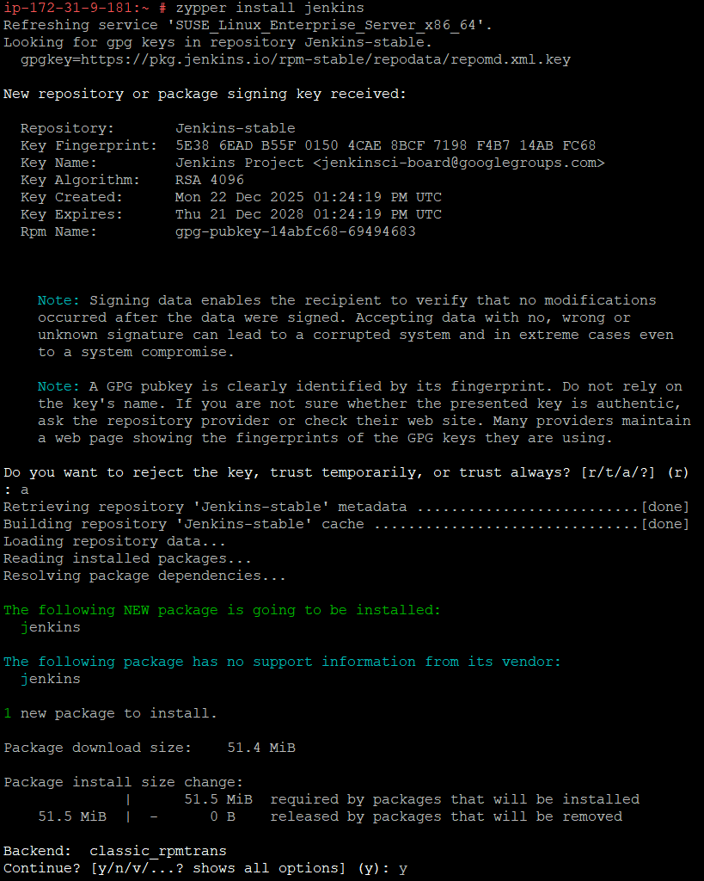
Enabled Jenkins:

Login to Jenkins:
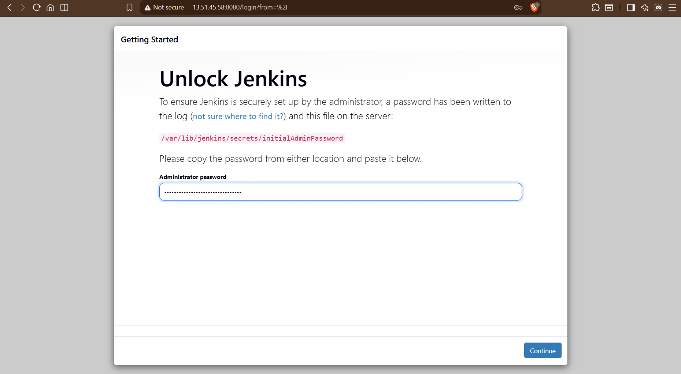
Plugin installation:
